Roanoke Valley Student Art Competition

BEST IN SHOW PRIZE: $200

Many other additional prizes available!

Open to all Public, private, and homeschooled students in the roanoke valley in grades k-12
If you love to draw, paint, or create other works of art and want a chance to win some great prizes, this is the contest for you!
Deadline for Submission is Friday, April 19, 2019.
Award Reception will be held on Saturday, May 4, 2019 from 1 to 3 P.M. at 2nd Helpings Shop Gallery Café.
Entry fee is $20 per student and includes one 12X12” canvas.
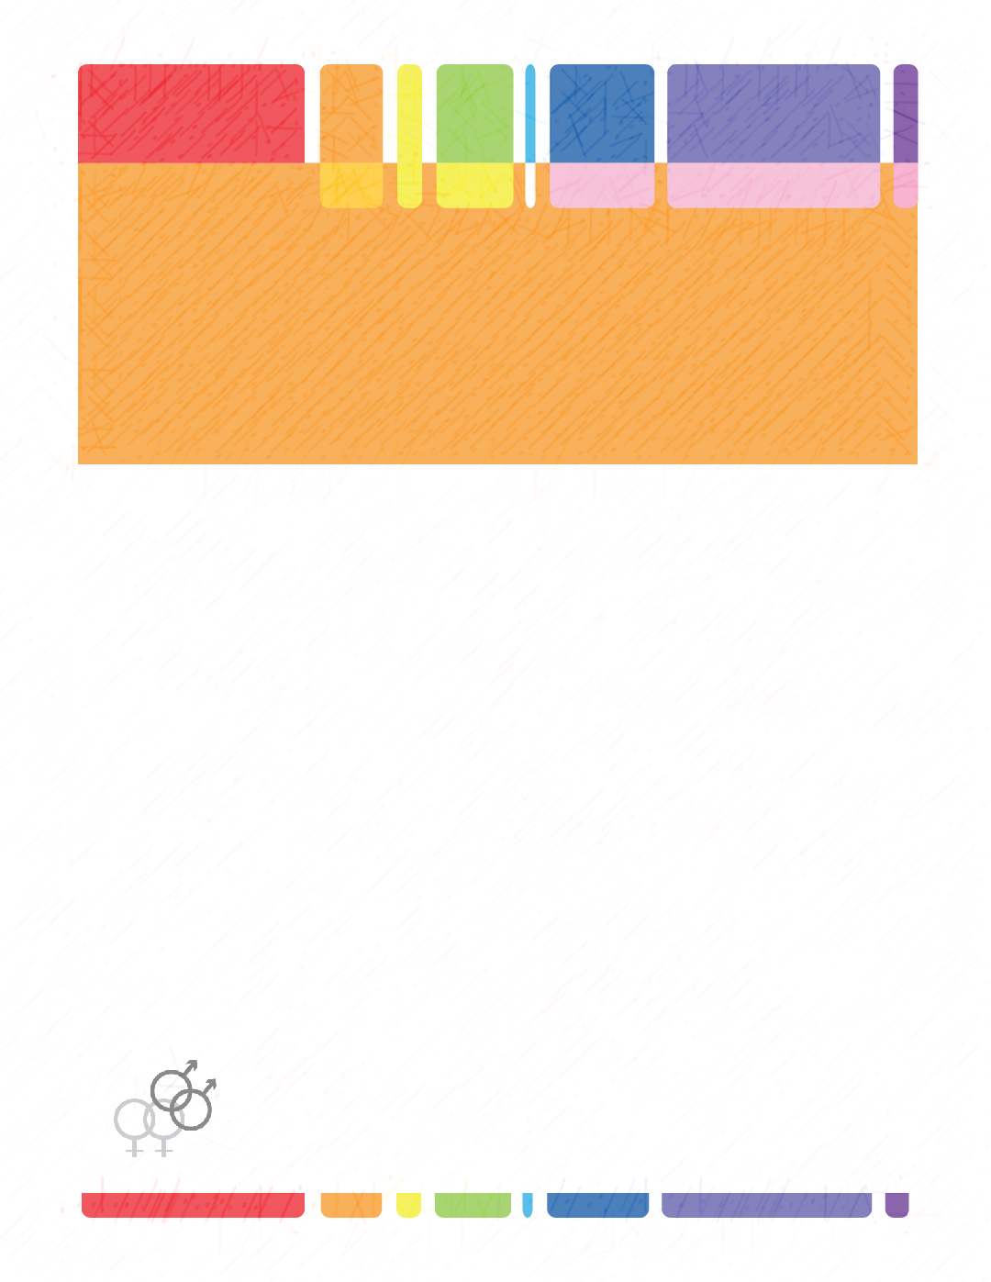
For details and a complete list of rules, please visit us at https://roanokevalleystudentartcompetition.com or on Facebook Roanoke Valley Student Art Competition. Email us at roanokevalleyartcompetition@gmail.com.
Sponsored by Bent Mountain Christian Academy, in conjunction with the Rescue Mission.

